**IoT-BASED SMART WATER CONSUMPTION SYSTEM**

**Phase-4**

**Introduction:**

A Smart Water Consumption System, powered by the Internet of Things (IoT), represents a cutting-edge technological solution that addresses the pressing challenges of water management, conservation, and efficiency. This innovative system leverages IoT technology to monitor, analyze, and optimize the utilization of water resources in various sectors, including residential, commercial, industrial, and agricultural.

At its core, the Smart Water Consumption System is designed to provide real-time data and insights into water usage, enabling individuals, businesses, and organizations to make informed decisions about water conservation and management. Through a network of interconnected sensors, data collection devices, and cloud-based platforms, this system offers a holistic approach to water consumption by integrating smart devices and data analytics

**Scope of the project:**

* The project is chosen with the motive of making others aware of the values of water so that they steps to prevent unnecessary wastage of water in the form of leakage and running water from the tap.
* The inclusion of IoT technology adds further advantage by eliminating the human work to record the water consumption readings and it indicates any malfunction in the device too.
* The main objective of the project is to measure the accurate volume of the water consumed and to send the data to the server via IoT.
* From the data received, one could witness their consumption
* In addition to sending the data to the server, it is also displayed locally using LCD.

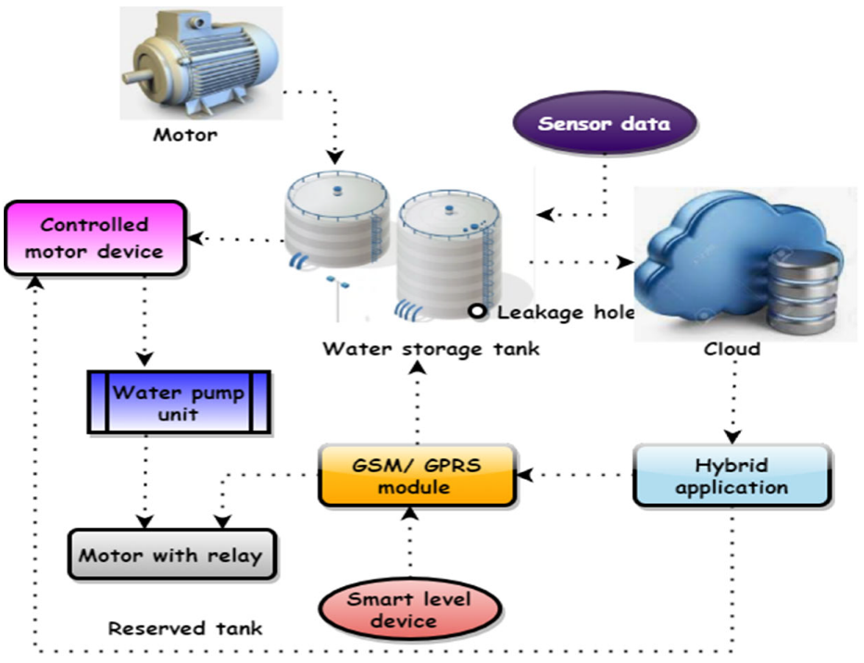

**Block Diagram:**

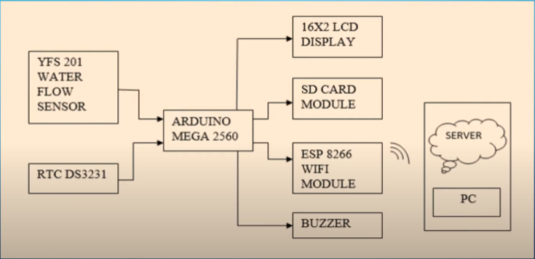

**Development Part:**

After the connection has been made then the software installation process has to be done and next, we will have to develop the existing mobile app. Before going to real-time working of the smart parking system, we can check our connections by simulation the model in a software application. Then we will integrate the model with an application by using the Blynk App.

**Arduino Ide and Application setup:**

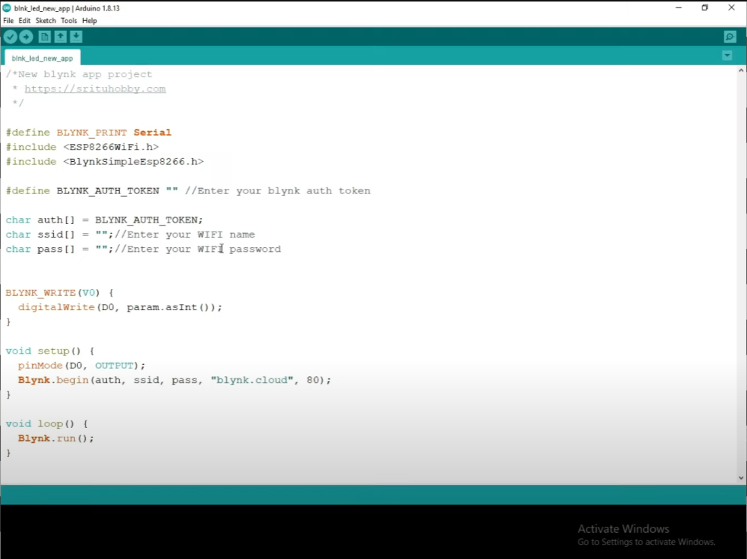

* Initially, we set up an Arduino board with connections, and later with the Bynk application.

Next step we move on the setting up the application as said earlier

* We register necessary details in the login page and and download app via Play Store

After downloading the application sign in and do the other required operation in the app

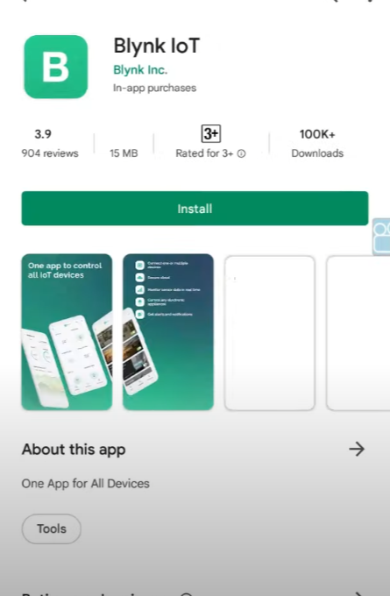

* Now we input the desired User Interface features in the app and change the entities according to our wish
* After clicking onto the add broker you must give your details like name, location, address and many more and save the details.
* You can also edit the details which has been given in the details section and save it. After you’ve done it, the toggle buttons will show up.
* We can add on the toggle button if needed and then we can edit the already existing toggle buttons and the newly created toggles by giving the buttons the on and off values and give colours to the buttons according to the on and off.

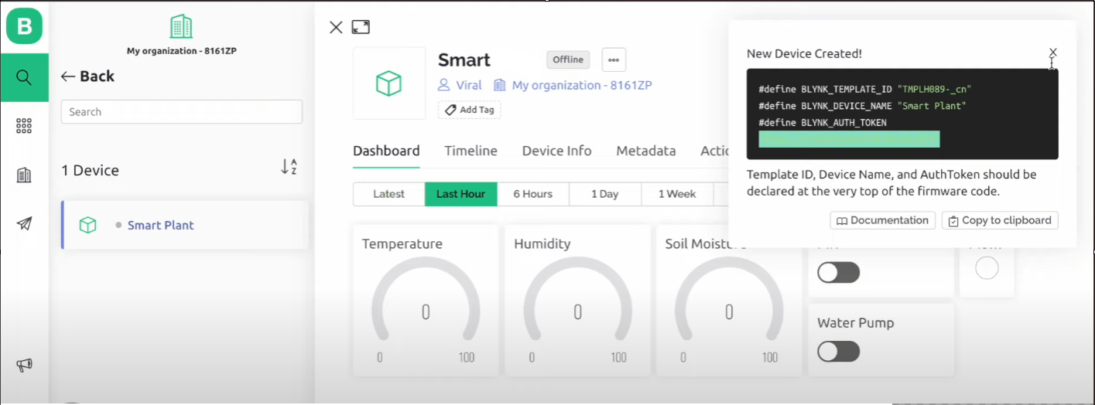

* After registering and uploading all details on the web page download the app to continue the next process which is to proceed with setting up the app interface and features we need
* In the app go on with the new project option add on all interface needs and prepare it for the slide to display the input we got from the IOT device system

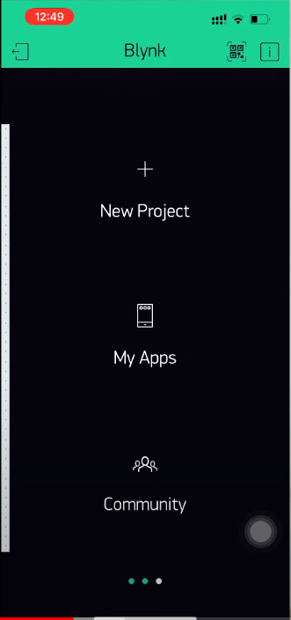

**Objectives of the Project:**

1. **Set Clear Objectives:**

Define the specific goals and objectives for the app update. This could include improving user engagement, fixing bugs, adding new features, or supporting new platforms.

1. **User Feedback and Analysis:**

Gather feedback from existing users through app reviews, surveys, and analytics. Analyze this data to identify pain points, feature requests, and areas for improvement.

1. **Update Planning:**

Based on user feedback, market research, and your objectives, create a detailed plan for the update. Define the scope, prioritize features, and set a timeline.

1. **Design Enhancements:**

If necessary, update the app's UI/UX design to improve user experience. Ensure that the app remains visually appealing and user-friendly.

1. **Bug Fixing:**

Prioritize and fix existing bugs and issues to ensure a stable and reliable app.

1. **Performance Optimization:**

Optimize the app's performance, especially if it's been experiencing slowdowns or crashes.

This may involve code optimization, database improvements, or server optimizations.

1. **New Features:**

Add new features or functionalities based on user feedback and market trends. Ensure these new features align with the app's core purpose and enhance its value.

1. **Testing and Quality Assurance:**

Thoroughly test the updated app to identify and resolve any issues. Use both automated and manual testing, and involve real users if possible.

1. **Security Review:**

Conduct a security audit to ensure the app is protected against potential vulnerabilities and threats.

1. **User Communication:**

Inform your existing user base about the upcoming update through email, push notifications, or in-app messages. Highlight the improvements and new features.

**Uses of the Smart Water Consumption System:**

A smart water consumption system using Internet of Things (IoT) technology offers various benefits and use cases in different domains. Here are some of the key uses of a smart water consumption system:

1. Water Conservation:

- Leak Detection: IoT sensors can detect water leaks in real time and alert users, reducing water wastage.

- Usage Monitoring: Track water consumption patterns and identify areas where water is being used inefficiently.

2. Agriculture:

- Soil Moisture Monitoring: Optimize irrigation by measuring soil moisture and weather conditions to prevent overwatering.

- Crop Watering Automation: Automatically control irrigation systems based on sensor data and crop requirements.

3. Residential and Commercial Buildings:

- Smart Faucets and Fixtures: IoT devices can control water flow, reducing consumption by turning off taps when not in use.

- Water Heater Control: Optimize water heating systems to save energy and reduce water usage.

- Appliance Integration: Monitor and control appliances like dishwashers and washing machines to use water more efficiently.

4. Industrial Applications:

- Process Optimization: IoT can help industries monitor and control water usage in manufacturing processes to reduce waste and improve efficiency.

- Cooling Systems: Efficiently manage cooling systems in industrial settings to minimize water consumption.

- Water Quality Monitoring: Ensure that water used in industrial processes meets quality standards.

5. Smart Cities:

- Water Distribution Management: Monitor and control water distribution systems to reduce leaks and improve supply efficiency.

- Public Water Usage Awareness: Inform residents about their water consumption to encourage responsible usage.